# Restaurant Management System User Manual

**Software required:**

* **Wamp Server,**
* **MS Access**

Steps for executing the application of Restaurant Management System

1. Install Wamp server
2. Extract the contents of RS folder into Wamp >www>RS folder
3. Open phpmyadmin
4. Create new database as online_rest
5. Click import and select the file online_rest from RS folder >SQL folder. This shall create the database there.
6. Create a MS ACCESS database and name it as online_rest.mdb.
7. Now open ODBC Data Source Administrator

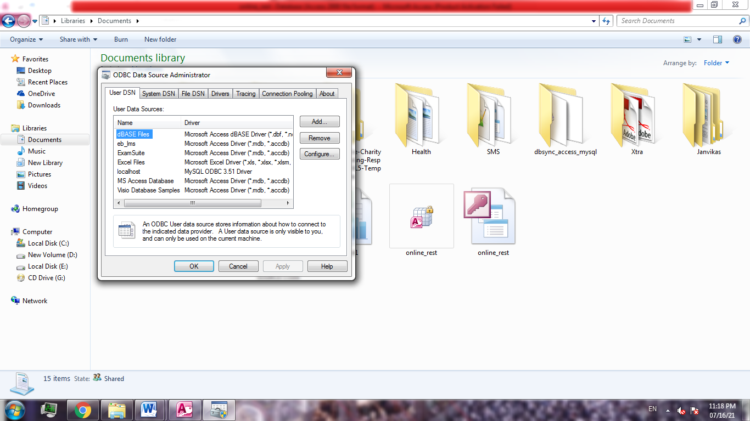

1. Click Add and select MySQL ODBC driver. If this driver is not present install it.

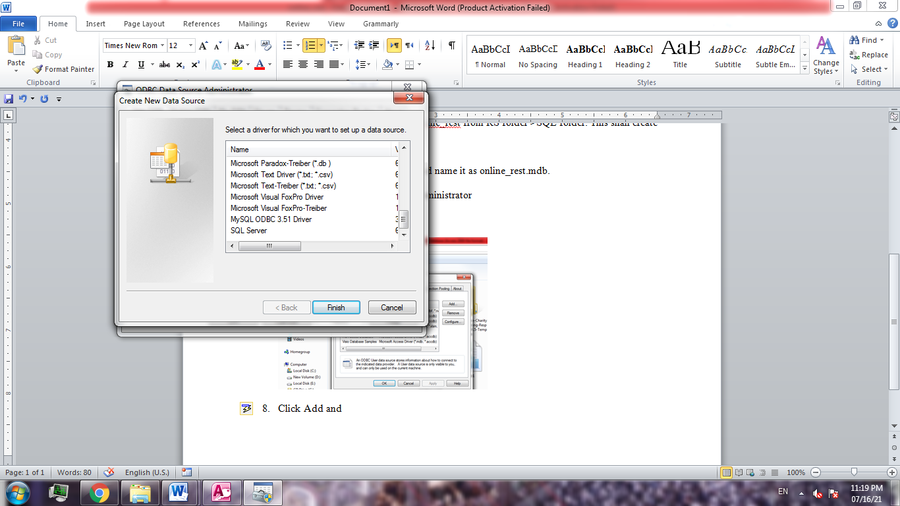

1. Click Finish. This shall open MYSQL connector, Write the datasource name as localhost, user as root and database as online_rest and leave all things blank and click ok.
2. Now open MS ACCESS database online_rest.mdb.
3. Click on External Data tab and select ODBC database.
4. Select Link to the datasource and click ok
5. Select Machine datasource, local host and add all the tables into the database. Your MS Access tables shall be linked and created.

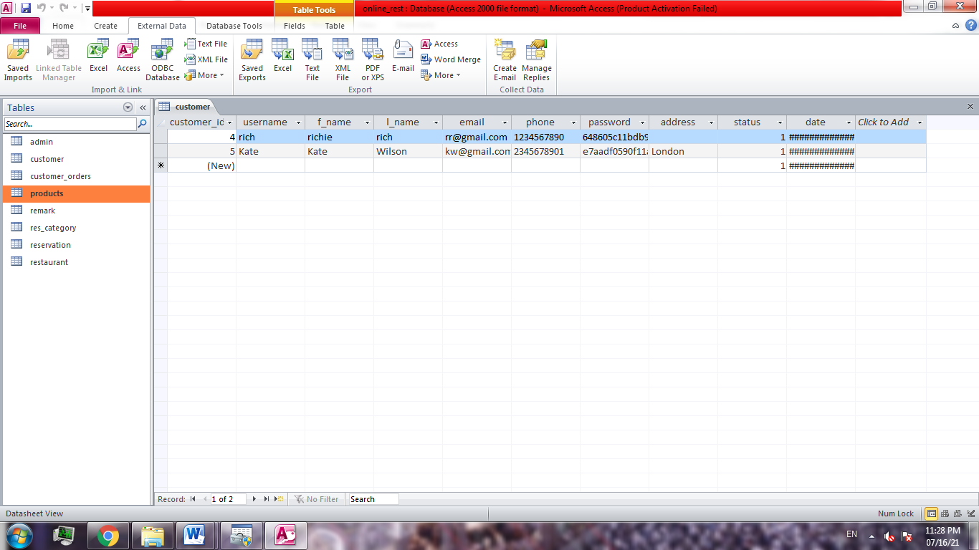

1. Now open localhost/RS/index.php

As a new customer create an account or enter login details

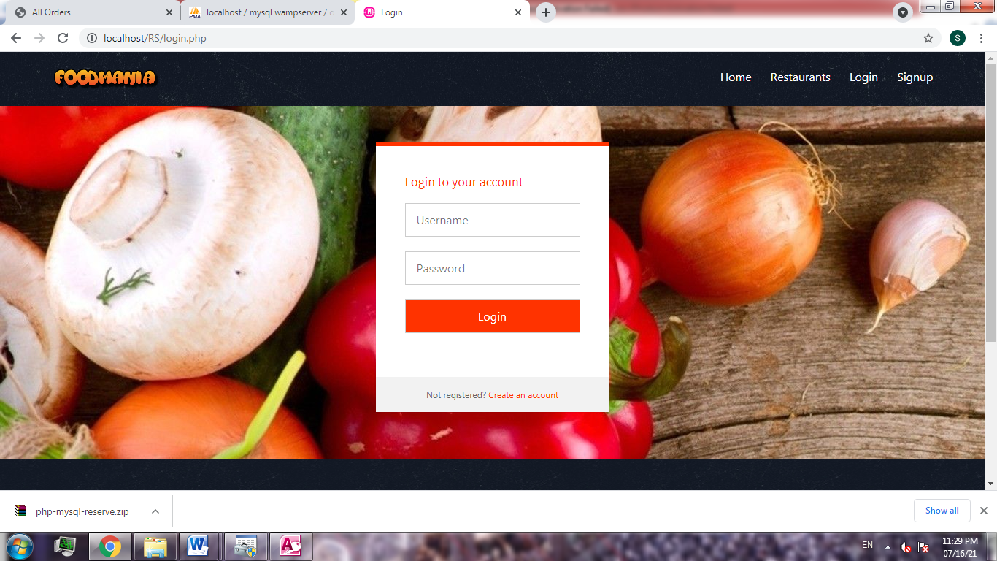

Now you can order dishes or make table booking

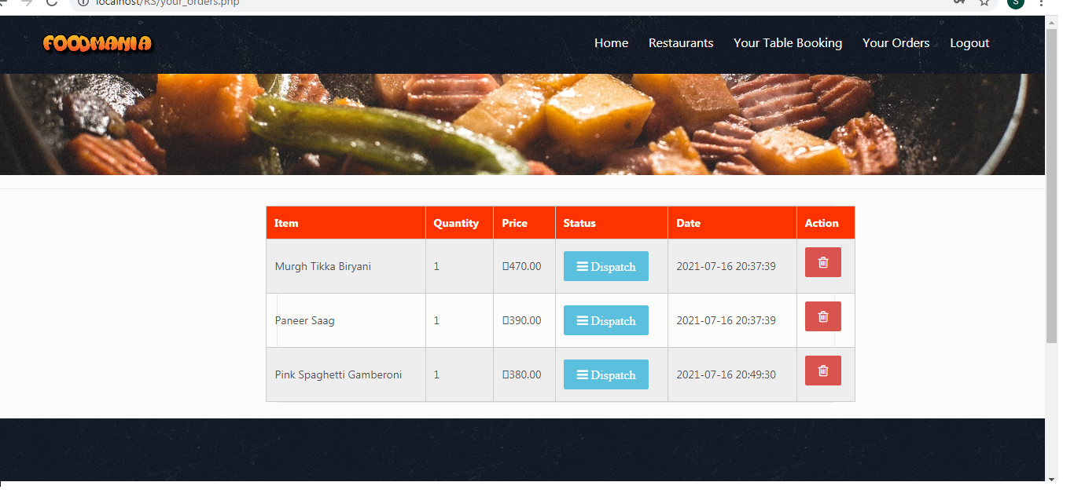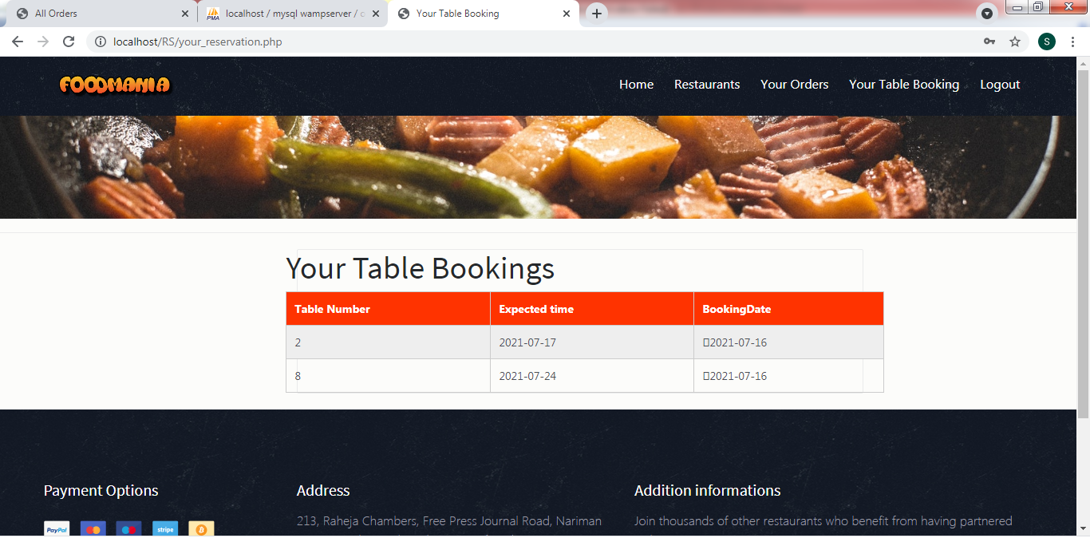

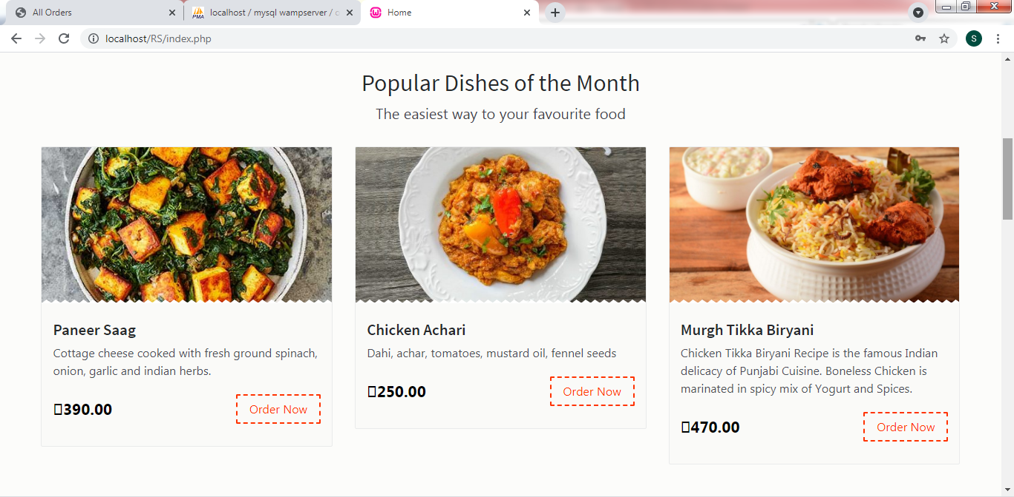

1. As an admin go to localhost/RS/admin/index.php and login as admin with username admin and password admin123

You can act and perform actions as admin

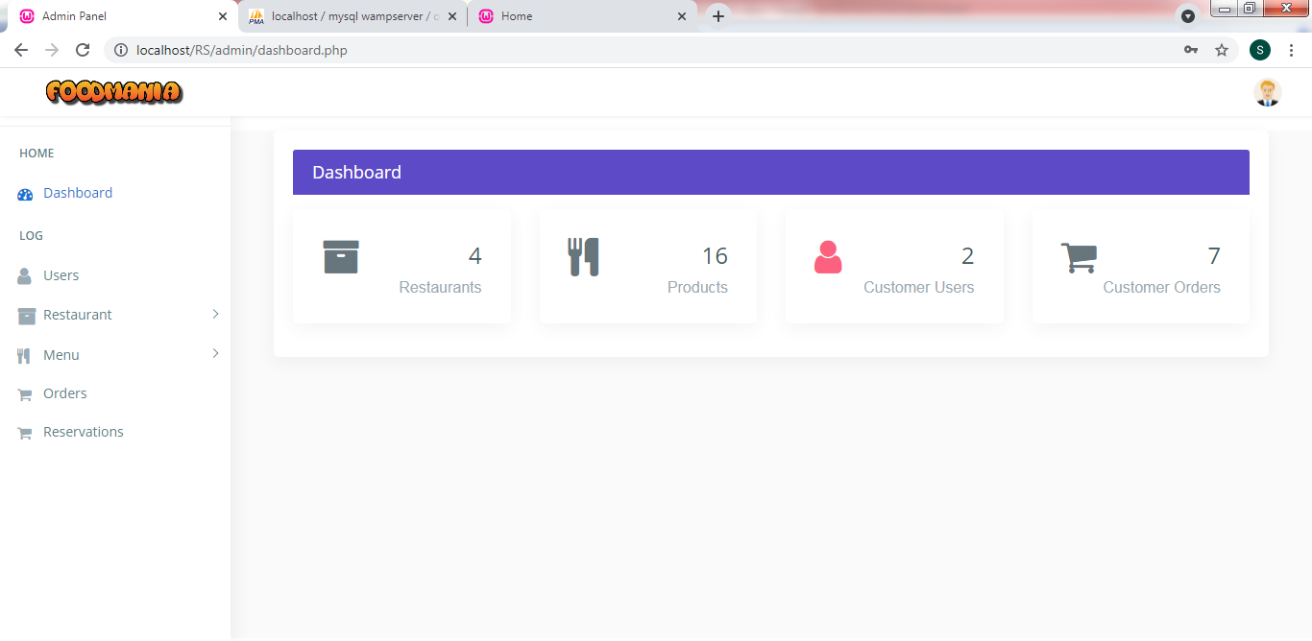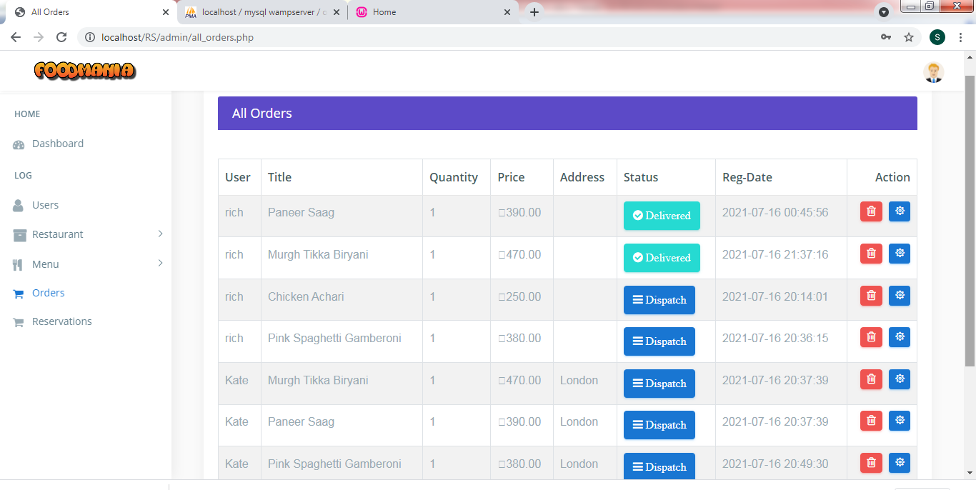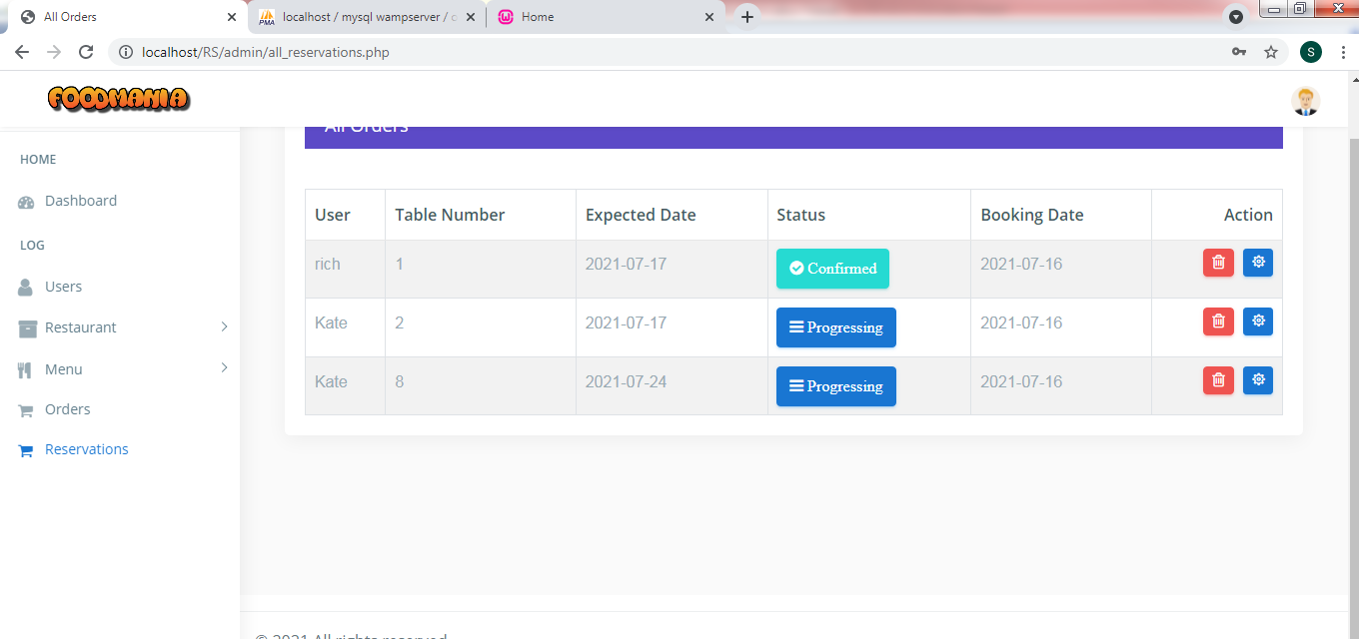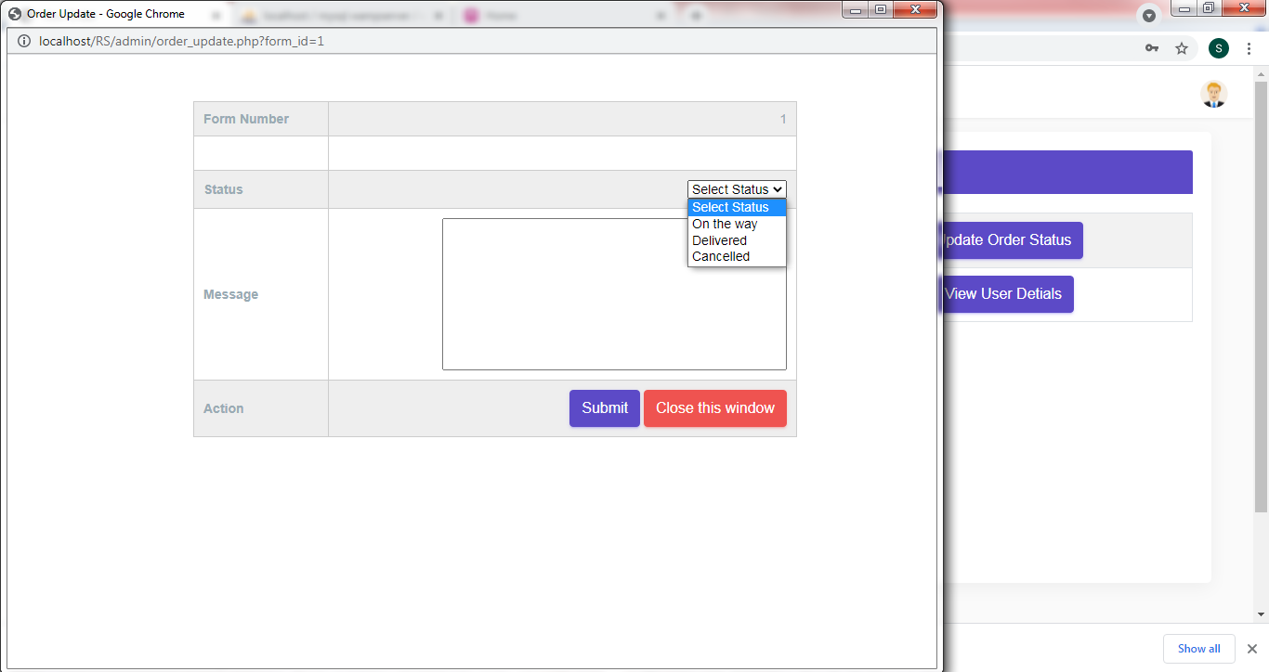

# ER Diagram

